Difference between Humans and Animals
We have often heard how plants are different from animals, how animals are different from humans, how plants are different from humans, and so on. No doubt, animals and humans are way too different in various aspects. Humans are the only living beings on earth who have the freedom to make decisions for themselves. Animals do not enjoy such liberty.
Animals live in a food chain, while humans do not follow any particular chain.
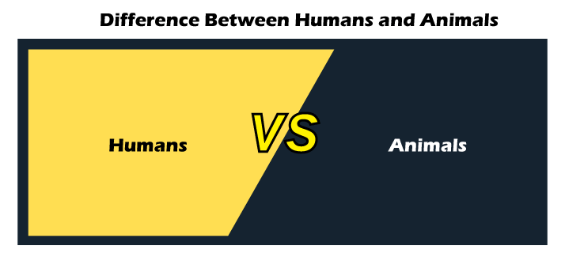
There are various differences between humans and animals. Let us look at some of the fundamental differences.
S.NO. | HUMANS | ANIMALS
1. | Humans are often called as 'Homo Sapiens.' This is the species that we belong to. | On the other hand, animals have a number of species.
2. | Humans are omnivorous beings, i.e., they can eat both vegetarian and non-vegetarian foods. | Animals can be carnivorous, herbivorous, or omnivorous. Animals like lions and tigers are carnivorous (survival on meat). Animals like a cow, sheep are herbivorous (survival on grass), and animals like bears, cockroaches are omnivorous (survival on both vegetarian and non-vegetarian foods).
3. | The weight of a human brain is 1.2 Kgs. | The size of the brain varies to the size of an animal. For instance, the brain of a blue whale weighs 6.90 Kg, while the brain size of an earthworm weighs 170-180 micrometers.
4. | Humans have the ability to reason upon certain things, and are driven by instincts, intellect, and logic. | Animals cannot reason, but they are only driven by their instincts.
5. | Humans are bipedal, i.e., they walk on two legs. | Animals are quadrupedal, i.e., they walk on four legs. Apart from aquatic animals and snakes, all animals walk on their four legs.
6. | Humans can express themselves to each other as they have a 'particular language' to speak in. | On the other hand, animals converse with each other, but they do not a particular language ton converse in. they lack the expressiveness of a human language.
7. | Humans have the ability to turn any kind of environment according to themselves. | Animals are incapable of changing the environment. Therefore, they can either adapt to the environment or die.
8. | Humans have various ways of survival and sustenance. | Animals are only dependent upon nature. So, they do not have any other means of survival.
So, these are the key differences between humans and animals. Humans have become much more advanced and know several ways to survive and sustain themselves. Animals do not have such survival techniques, and therefore, they are only dependent upon nature for food. We have the ability to speak the complex language, use our logic and intellect to reason. But animals only do their actions based on instincts. Well, it is interesting to note that both humans and animals primarily use their instincts to figure out certain things.
One of the most important differences between humans and animals is that we have the power of imagination. We are capable of changing the situation and environment according to our wishes and favors. But animals lack this power of imagination, and due to this they are incapable of changing environments. They are primarily dependent on nature for their survival. Well, it is interesting to note that chimpanzees are called as the 'human animal.' This is because they are the smartest animals on the planet. They are capable of doing certain things that other animals are incapable of. On the other hand, animals like koala bears, sloth bears are the slowest animals on the planet.
Well, apart from the differences, humans, and animals are also similar in certain aspects. So, let us look at some interesting facts about them.
- Humans and animals have the ability to pick and choose their social groups. Just like humans, animals also choose their groups based on their preferences.
- Humans and cows have similar sounds. For instance, the human sound of 'Hmm' and the animal (cow) sound of 'Moo' is quite the same.
- Just as humans, some animals tend to be homosexual. For instance, in the animal kingdom, sheep are mostly considered as a homosexual animal. Sheep is probably the only animal who is homosexual.
- Both humans and animals depict their emotions through a tone or sound.
- Humans and animals have an interdependent relationship. For instance, humans who pet animals are provided with emotional support, comfort, and security. Animals are a kind of stress reliever in our lives.
- Chimpanzees are quite the same as human beings as they have certain abilities as humans. Chimpanzees are considered as the smartest animals in the animal kingdom.
So, these are some similarities between humans and animals. Well, there is one more interesting fact to know, that a leech has 32 brains and a hagfish has four hearts. These are two distinctive and vivid species of animals in the animal kingdom. Humans and animals have various differences, but they also have certain similarities. The differences and similarities are already mentioned above. Humans and animals are interdependent. If we pet animals, love them and provide them food, they will provide us affection, security, love, and care. Thus, both humans and animals have certain similarities, despite having several differences.

